

MARMARA UNIVERSITY
FACULTY OF ENGINEERING
PHYS1104
PHYSICS LABORATORY II

EXPERIMENT 7
Magnetic Field Of Solenids

Section: PHYS1104
Submitted to: Prof. Dr. MURAT DOĞRUEL

 | Department | Id Number | Name & Surname | Contribution
1 | EEE | 150721032 | Yiğit Yektin | Purpose,Theory,Conclusion,Calculations
2 | EEE | 150720062 | Mehmet Ali Kamalak | Preparing Document, Calculations
CONTENTS
4
1.Purpose
4
2.Theory
3. Experimental Setup 5
3.1 Equipment List
4. Conclusion
5

Table of Tables
--Table 1: B values along z-axis of the (100 wdg) solenoid
--Table 2: B values along z-axis of the (200 wdg) solenoid
--Table 3: B values along current of the (300 wdg) solenoid

Purpose
In this experiment we tried to measure magnetic flux density along the axis of solenoid. We used a hall probe. And we also determine the magnetic permeability of the air $μ_{0}$ experimentally.
Theory
From Ampere’s Law, the magnetic flux N turn solenoid in free space is
(1)
$$\oint{\overset{⃑}{B}d\overset{⃑}{l}= μ_{0}NI}$$
(2)
$$B=\frac{μ_{0}NI}{L}$$
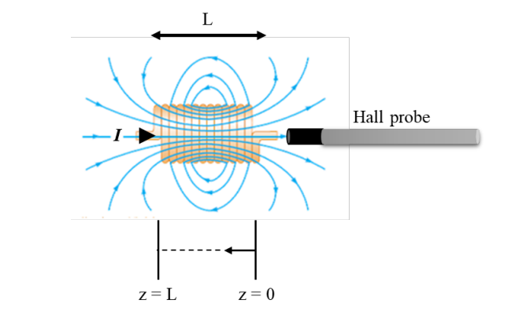

In this figure magnetic field lines for a tightly wound solenoid of finite length with a hall probe to measure the magnetic field intensity along the z axis.

Where L (m) is the length of a solenoid, I (A) is the current flowing through the solenoid, B (T) and $μ_{0}$ are the magnetic flux density and permeability of the free space respectively. The teoritical value of $μ_{0}$ is equal to $1.26×{10}^{-6} T.m/A$.

Equation 2 is valid only for points near the center of a very long solenoid. As a result, the magnetic field intensity is stable and higher at the center, smaller at the ends.

Experimental Setup
Equipment List
- Circuit Board $×1$
- Digital Multi-Meter $×1$
- Cables
- Gaussmeter with DC Hall Probe $×1$
- G-clamp $×1$
- Support Rod $×1$
- Ruler $×1$
- 100 Turns Solenoids (L=0,043m) $×1$
- 200 Turns Solenoids (L=0,090m) $×1$
- 300 Turns Solenoids (L=0,143m) $×1$

Conclusion
First, we start the measurement with 100 turn solenoid. We set the current to 0.5 A. And we measured each 0.5 cm from start of the Hall Probe to the end of the Hall Probe. Secondly, we measured with 200 turn solenoid. We also set the current same in this solenoid measurement. And we measured each 0.5 cm from start of the Hall Probe to the end of the Hall Probe. Thirdly, we measured with 300 turn solenoid. In this solenoid measurement we change the current 0.5 in each measurement and note them in the laboratory sheet. In this experiment we saw that the magnetic field becomes the maximum in the center of solenoid and it decreases to the end.
Z(cm) | B(mT)
0 | 0
1 | 0.6
2 | 0.8
3 | 1.1
3.5 | 1.1
4 | 1.1
5 | 1
5.5 | 0.7
6 | 6
6.5 | 0.3
7 | 0.2
7.5 | 0.1
8 | 0
Table 1: B values along z-axis of the (100 wdg) solenoid

Experimental $μ_{0}$= 4.9*10^(-4)
Percentage Error in $μ_{0}$= 4.9

Z(cm) | B(mT)
0 | 0
0.5 | 0.2
1 | 0.4
1.5 | 0.5
2 | 0.7
2.5 | 0.9
3.5 | 1.2
4 | 1.2
4.5 | 1.2
6 | 1.2
9.5 | 1
10 | 0.7
10.5 | 0.5
11 | 0.4
12 | 0.2
Table 2:B values along z-axis of the (200 wdg) solenoid

Experimental $μ_{0}$= 0.0618*10^(-2)
Percentage Error in $μ_{0}$= 4.1

I(A) | B(mT)
0.5 | 1.6
0.45 | 1.4
0.4 | 1.2
0.35 | 1.1
0.25 | 0.9
0.2 | 0.7
0.15 | 0.5
0.1 | 0.4
0.05 | 0.2
Table 3: B values along current of the (300 wdg) solenoid.

Experimental $μ_{0}$= 7.62*10^(-4)
Percentage Error in $μ_{0}$= 6.06

